Nature of Invention: Process design

**Applicant:** ChemiEvolve Industries

**Inventors:** Akash Kumar Gupta(220095), Manas Dhakad(220610) ,Raj Patel(220860) , Adarsh Pal(220054)

**Chemical Formula: (C6H6O.CH2O)n**

**Chemical Name:** Polyoxybenzylmethyleneglycolanhydride(Phenol-Formaldehyde Resin)

**Process Title:** Phenol Formaldehyde Resin Formation

**Process Description:**

**Formaldehyde Formation:**

**Block Diagram:**

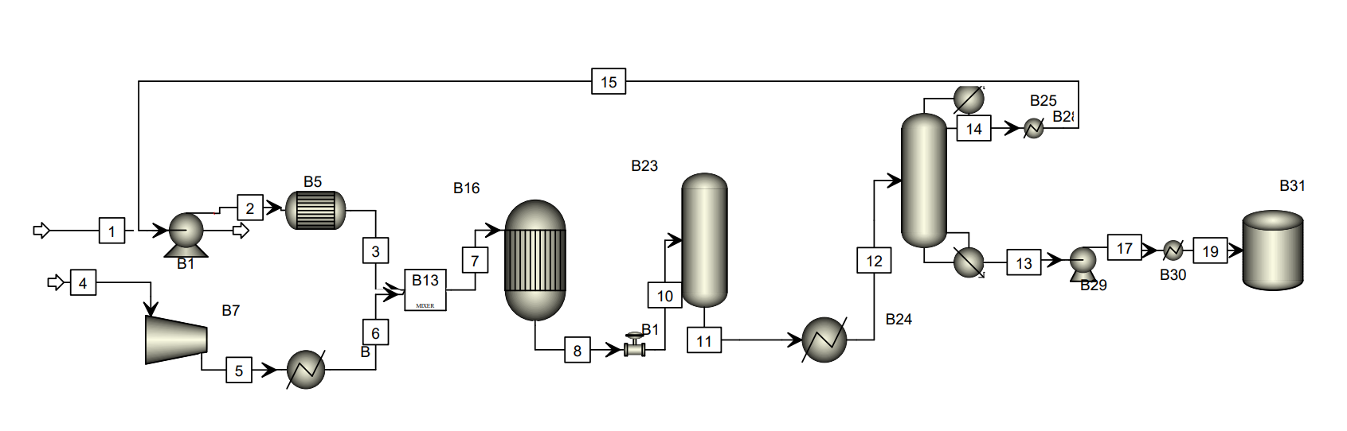

B33

B32

**Equipment Labelling**

**Pump:** B1, B29

**Mixer:** B13

**Compressor:** B17

**Heat Exchangers & Boilers:** B24, B30, B28, B25, B30 ,B33

**Reactors:** B5 ,B­16

**Distillation Column:** B23 ,B32

**Storage:** B31

**Process Conditions**

Overall Temperature range should be between 250-400oC.

**Mass Balance & Stream Labelling**

|  |  |  |
| --- | --- | --- |
| **Stream No.** | **Component(s)**  **(C)** | **Flow Rate**  **(R)** |
| 1 | Methanol | 412 kg/day |
| 15 | Recycled Methanol | 45.68 kg/day |
| 2,3 | Methanol | 457.68 kg/day |
| 4,5,6 | Air | 889.33 kg/day |
| 7,8,10,11,12 | Methanol + Air | 1347.01 kg/day |
| 13,17,19 | Formaldehyde | 386.88 kg/day |
| 14 | Methanol | 46.1 kg/day |

**Bakelite Formation:**

**Block Diagram:**

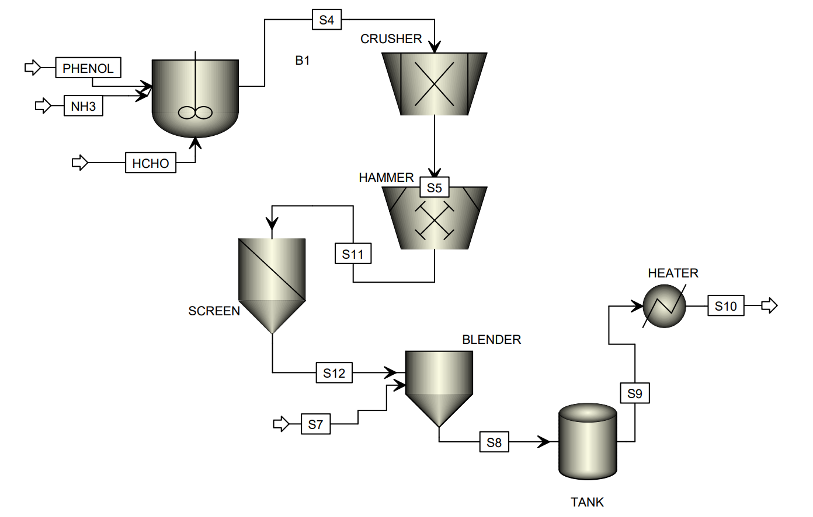

CSTR

**Process Conditions**

Temperature: 60-100 oC and use reduced pressure conditions.

**Mass Balance & Stream Labelling**

|  |  |  |
| --- | --- | --- |
| **Stream No.** | **Component(s)**  **(C)** | **Flow Rate**  **(R)** |
| Phenol stream | Phenol | 606.66 kg/day |
| NH3 stream | NH3 | 219.23 kg/day |
| HCHO stream | HCHO | 386.88 kg/day |
| S4,S5,S11,S12 | Phenol+NH3+HCHO | 1212.77 kg/day |
| S7 | Water | 170.87-893.6 kg/day |
| S8,S9 | S7+S12(blended) | 1383.64-2106.37 kg/day |
| S10 | Phenol Formaldehyde Resin | 1000 kg/day |

**Capital cost (only for the reactor):**

|  |  |  |
| --- | --- | --- |
| **Reactors** | **Capacity**  **(litre)** | **Cost**  **($)** |
| For Formaldehyde | B5 Reactor of 578.32L and B16 of 1347L | 26,200 |
| For Bakelite Formation | 1300 L | 21,300 |
|  |  | **Total cost = $47,500** |

**References:**

1. <http://www.matche.com/equipcost/Reactor.html>

**List the contributions of each author:**

* **AKASH KUMAR GUPTA** and **ADARSH PAL** calculated the respective flow rates in the streams of the diagram and computed the capital cost of the reactors.
* **MANAS DHAKAD** and **RAJ PATEL** converted the lab scale design of the process flow into an industrial design design and performed the scale up process.

**Sign the pdf and upload.**

|  |  |  |
| --- | --- | --- |
| Name | Roll No | Signature |
| Aadityaamlan Panda | 220007 |  |
| Akash Kumar Gupta | 220095 |  |
| Manas Dhakad | 220610 |  |
| Adarsh Pal | 220054 |  |
| Raj Patel | 220860 |  |